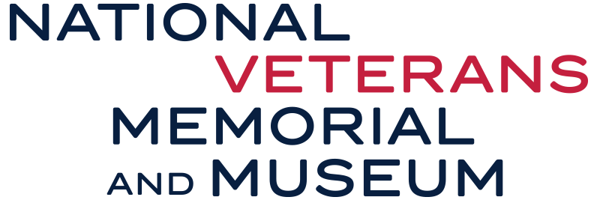

FOR IMMEDIATE RELEASE:
COLUMBUS, OHIO
JUNE 11, 2019

The National Veterans Memorial and Museum is Certified Sensory Inclusive

KultureCity has partnered with the National Veterans Memorial and Museum to make all of the exhibits, programs and events sensory inclusive. This new initiative will promote an accommodating and positive experience for all guests.

The National Veterans Memorial and Museum is the first museum in Columbus to be certified as sensory inclusive by KultureCity, a leading non-profit recognized nationwide for effecting change for those with sensory needs.

The certification process entailed the staff at the National Veterans Memorial and Museum being trained by leading medical professionals on how to recognize those guests with sensory needs and how to handle a sensory overload situation. Sensory bags, equipped with noise-canceling headphones, fidget tools and verbal cue cards also will be available to all guests at the National Veterans Memorial and Museum who may feel overwhelmed by the environment.

“The National Veterans Memorial and Museum was built for everyone and it is important to ensure an inclusive experience for all guests,” said Andy Cloyd, associated director of visitor experience at the National Veterans Memorial and Museum.

Sensory sensitivities or challenges with sensory regulation are often experienced by individuals with autism, dementia, PTSD and other similar conditions. With its new certification, the National Veterans Memorial and Museum is now better prepared to assist guests with sensory sensitivities in having the most comfortable and accommodating experience possible when attending.

Prior to attending an event, families can download the free KultureCity App where one can view what sensory features are available and where they can access them. Also, on the App is the Social Story, which will provide a preview of what to expect while visiting the National Veterans Memorial and Museum.

“To know that you soon will be able to see families attend a true community binding experience, with their loved ones who have a sensory challenge and who were not able to previously attend, is truly a heartwarming moment. Our communities are what shapes our lives and to know that the National Veterans Memorial and Museum is willing to go the extra mile to ensure that everyone, no matter their ability, is included in their community is amazing.” Dr. Julian Maha, Co-Founder, KultureCity.

CONTACTS: Koryn Naylor | koryn@hinsonltd.com | 614.416.7100 | c. 614.441.2372

###

About KultureCity
KultureCity is a leading non-profit recognized nationwide for using their resources to revolutionize and effect change in the community for those with sensory needs; not just those with Autism. Since the program’s inception, KultureCity has created over 200 sensory inclusive venues in 3 countries; this includes special events such as: NFL Pro-Bowl, NFL Super Bowl, MLB All Star Weekend. KultureCity has won many awards for its efforts: NASCAR Betty Jane France Humanitarian Award in 2017, Cleveland Cavaliers’ Quiet Space Sensory Room at Quicken Loans Arena was a finalist for the 2018 Stadium Business Award, and the 2018 Clio Sports Silver for social good in partnership with Cleveland Cavaliers/Quicken Loans Arena. Recently, KultureCity was awarded one of the World’s Most Innovative Companies for 2019 by FastCompany.

About the National Veterans Memorial and Museum
With more than 20 million living veterans throughout the United States, from our Greatest Generation to our recent heroes coming home from Afghanistan and Iraq and all who served in peace and war, the time for America to remember and to honor its veterans is now.

The National Veterans Memorial and Museum is neither a war memorial nor a military branch-of-service museum. National Veterans Memorial and Museum takes visitors on a narrative journey telling individual stories and shared experiences of veterans throughout history. It pays tribute to the sacrifices of servicemen and women and their families. History is presented in a dynamic, participatory experience with photos, letters and personal effects, multi-media presentations, and interactive exhibits. Together, these elements link our national story to the larger context of world events since our country’s earliest days and demonstrate the importance of individuals in shaping our history.

Please visit https://www.nationalvmm.org/ to learn more about the National Veterans Memorial and Museum.

